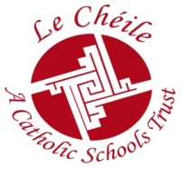 | Le Chéile Schools Trust Conference  January 2018 Hodson Bay Hotel, Athlone
- How would you rate the conference arrangements? Please indicate by circling a score below:
Ex. VG Good Satisfactory Unsatisfactory
Notice and organisation: 5 4 3 2 1
Hotel service / accommodation: 5 4 3 2 1
Conference and seminar rooms: 5 4 3 2 1
Food: 5 4 3 2 1
Location: 5 4 3 2 1
New Time Schedule/Format 5 4 3 2 1

Comments:

______

______

2. Workshop Ex. VG Good Fair
Workshop Title : 4 3 2 1

Comment: ____________

______

______

- Overall comment and suggestions for next year (including venue/location, speakers, format):

Potential Venues for 2018; please select your preferred options 1-4

Red Cow Morans Hotel | Dublin City West Hotel | Galway Bay Hotel | Hodson Bay Hotel
These hotels can provide 2 large meeting rooms and sufficient bedrooms in an out of town location.

Please leave completed form, along with your name badge, in the box at the Registration table as you leave.
Thank You, Slán Abhaile

