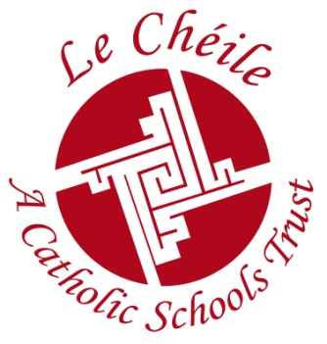

Le Chéile Schools Trust – Information for Parents Associations, Websites, Year Books etc.
The Le Chéile Schools Trust is a trust body acting on behalf of the fourteen congregations and over fifty schools, who wished to continue:

• To affirm their commitment to the future of Catholic Education
• To provide for the needs of the students and communities in the their schools
• To honour their partnership with the government in the educational system
Our Schools
In a spirit of partnership and collaboration, the Le Chéile Schools Trust supports and encourages schools to be true to the three aims outlined above. The Trust also supports schools in promoting their individual tradition and heritage while at the same time encouraging the development of a Le Chéile identity that recognises common Catholic values and ethos across all its schools.

Students & Teachers
The Le Chéile Trust facilitates the sharing of ideas and expertise through a network of cluster meetings and training days. Students from our different schools come together at our annual conference to participate in group activities, discussing topical issues that impact upon their education and their experience of school.

Parents
Le Chéile recognises the important role played by parents in the education of their children. With this in mind schools are invited to include parents among the delegates at our annual conference.

Le Chéile, in partnership with the National Parents Council, invite Parents Associations from different Le Chéile schools to meet each other through a training programme offered at three different locations in November.

Members (non – directors) of Le Chéile Schools Trust
Membership of the Le Chéile Schools Trust comprises Patron Members and Schools Members.
1. The Patron Members are the members of the congregations, appointed by the Provincial Leader (two per congregation).
2. The School Members consist of two representatives nominated by each of the Boards of Management of the schools and admitted to membership by the Board of Directors. Their term of office is subject to and, is coterminous with, the Term of Office of the relevant Board of Management.

• Every member will use their best endeavours to promote the object and interests of the Company and observe all of the Company’s regulations.
• Members of the Company are not be entitled to remuneration for their services.
• A register is be kept by the Company containing names and addresses of all members.
The Structure of the Board of Directors of Le Chéile.
There are fourteen people on the Board:
2 representing the Síol Board of Directors
6 nominated as experts in some aspect of the work of the Board
6 nominated by the schools according to “clusters”
The Board of Directors is chaired by Dr. Anne Looney, CEO, National Council for Curriculum and Assessment.

The Company has an Annual General Meeting which is generally held at the same time as the annual conference.

The Le Chéile Charter is our foundational document and offers inspiration and guidance for our work in the future.
The charter is available on the Le Chéile website www.lechéiletrust.ie , which also contains the Le Chéile Hymn, regularly updated news, publications and resources.

The Le Chéile Prayer

In the power of the Spirit
and in keeping with the traditions of our founding
Congregations we pray that,
for students and teachers alike;
our schools
may be places of learning and discovery
places of hope and joy
places of courage and confidence
places of gratitude and generosity
places of faith rooted in love.
We make this prayer through Christ our Lord
Amen.

Paidir Le Chéile

I gcumhacht an Spioraid
Agus de réir thraidisiúin ár nOrd Bunaithe
Do mhic léinn agus do mhúinteoirí araon
Guímid go mbeidh
Ár gcuid scoileanna
Ina n-ionaid foghlama agus fionnachtana
Ina n-ionaid dóchais agus áthais
Ina n-ionaid misnigh agus muiníne
Ina n-ionaid buíochais agus móraigeantachta
Ina n-ionaid creidimh fréamhaithe sa ghrá.

Sin é ár nguí tré Chríost ár dTiarna
Amen

